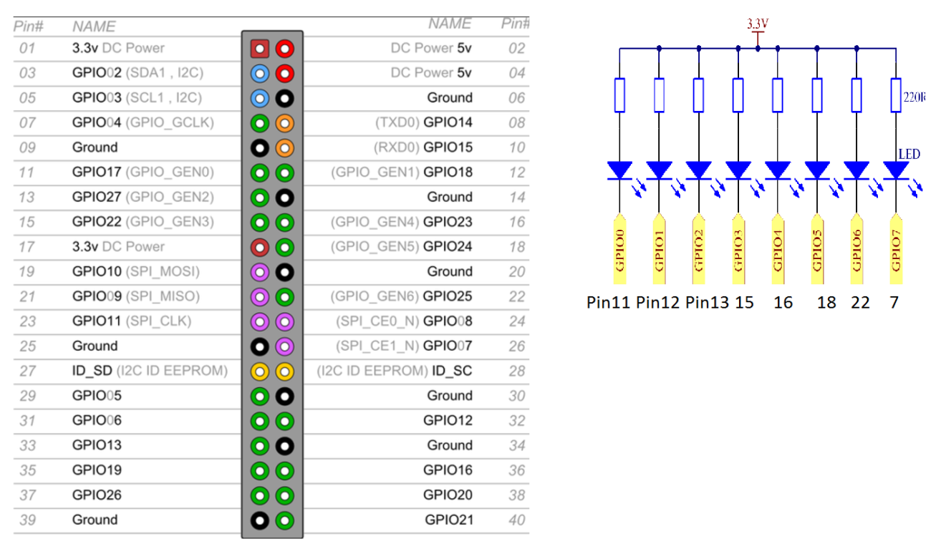

**import RPi.GPIO as GPIO # include GPIO library in RPi**

**import time # include time system call in Raspbian**

**pins = [11, 12, 13, 15, 16, 18, 22, 7] # put all pinNO in a list data type, like array**

**def setup():**

**GPIO.setmode(GPIO.BOARD) # using board pin number**

**for pin in pins: # 1st iter. pin = 11, 2nd iter pin = 12,… …**

**GPIO.setup(pin, GPIO.OUT) # Set all pins' mode is output**

**GPIO.output(pin, GPIO.HIGH) # Set all pins to high(+3.3V) to switch off led**

**# pin11 = 1, pin12 = 1, … … pin7 = 1**

**def loop():**

**while True: # forever loop**

**for pin in pins: # 1st iter. pin = 11, 2nd iter pin = 12,… …**

**GPIO.output(pin, GPIO.LOW) # # 1st iter.Pin11 = 0, switch on 1st led**

**time.sleep(0.05) # holding sw on 0.05Sec**

**GPIO.output(pin, GPIO.HIGH) # 1st iter.Pin11 = 1, switch off 1stled**

**for pin in reversed(pins): # reversed() function**

**GPIO.output(pin, GPIO.LOW) # 1st iter.Pin7 = 0, switch on 1st led**

**time.sleep(0.05)**

**GPIO.output(pin, GPIO.HIGH)**

**def destroy():**

**for pin in pins:**

**GPIO.output(pin, GPIO.HIGH) # turn off all leds**

**GPIO.cleanup() # disable GPIO port**

**# --------- main function ---------------------**

**setup()**

**try:**

**loop()**

**except KeyboardInterrupt: # When 'Ctrl+C' is pressed, the child program destroy() will be executed.**

**destroy()**

[**https://learn.sunfounder.com/category/super-kit-v3-0-for-raspberry-pi/**](https://learn.sunfounder.com/category/super-kit-v3-0-for-raspberry-pi/)